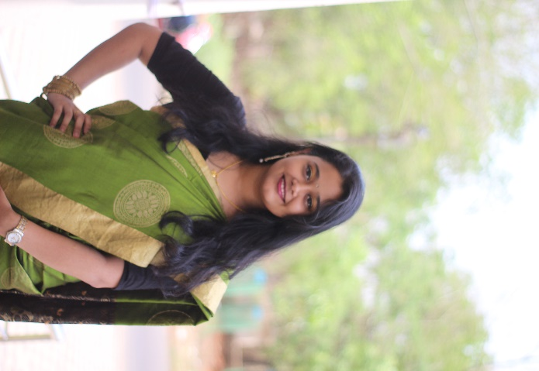**Tanushree Jena**

Plot no-89/A, Kalpana

Area, BJB Nagar,

Bhubaneswar,

Odisha,751014

*Mobile*: +91-6370222073

*E-mail: tanushreejena09@gmail.com*

**Career Objective**

|  |  |  |  |  |
| --- | --- | --- | --- | --- |
| **Education** | |  |  |  |
| **Qualification** | **School / College** | **Board /** **University** | **Year of Passing** | **Percentage/** **CGPA**  **Secured** |
| BCA | UTKAL UNIVERSITY | Utkal University | 2023 | ----------- |
| Higher secondary | BUXI JAGABANDHU ENGLISH MEDIUM SCHOOL,  BHUBANESWAR | CBSE, ODISHA | 2020 | 67.8% |
| Secondary | BUXI JAGABANDHU  ENGLISH MEDIUM  SCHOOL,  BHUBANESWAR | CBSE,  ODISHA | 2018 | 78% |
| **Strength** | |  |  |  |  |

To join an organization where I can utilize my knowledge and moral skills to add value to the organization and which will give me experience of corporate sector and will enhance my knowledge.

Confident

Determination

Dedication

Time Management

Hardworking

**Technical Skills**

C, C++, HTML, SQL

|  |  |
| --- | --- |
| **Hobbies and Interests** |  |
| Painting  Crafting  Dancing  Gardening |  |
| **Personal Profile** |  |
| **Date of Birth** | **: 9**th Jun ,2002 |
| **Gender** | **:** Female |
| **Father’s Name** | **:** Tapas Kumar Jena |
| **Mother’s Name** | **:** Kalpana Jena |
| **Marital Status** | **:** Single |
| **Conversant In** | **:** English, Hindi, Odia |
| **Address.** | **:** Plot no-89/A, Kalpana Area, BJB Nagar, Bhubaneswar  PO: BJB Nagar, District: Khorda, State: Odisha,  PIN:751014 |
| **Alternate Phone No** | **:** +91-6371112657 |
| **Declarations** |  |

I do hereby declare that all the statements mentioned above are correct to the best of my knowledge. I bear the responsibility for the correctness of the above-mentioned statements.

**Place: Bhubaneswar Tanushree Jena**